- Ethernet Standard & Specification

Q.1 Draw a simple diagram showing the pin layout of an RJ-45 connector and label the color codes for the T568A and T568B Ethernet wiring standards?

Answer

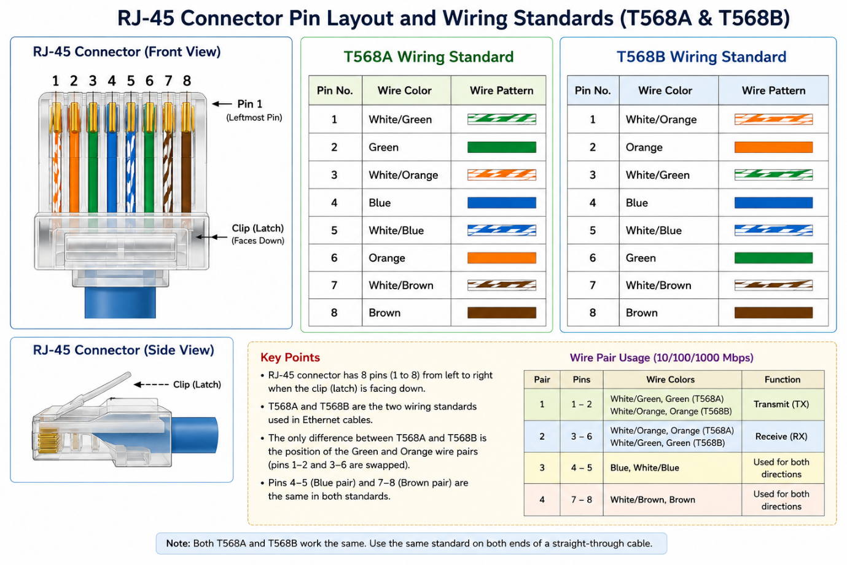

- The RJ-45 connector has 8 pins. T568A and T568B are two Ethernet wiring standards. Both use the same wire colors, but the orange and green pairs are placed in different pin positions. In T568A, the green pair comes first, while in T568B, the orange pair comes first. The blue and brown pairs remain in the same positions in both standards.

Q.2 Create a table comparing the key specifications of Ethernet standards 10BASE-T, 100BASE-TX, and 1000BASE-T, including speed, cable type, maximum cable length, and connector type?
Answer

- Comparison of Ethernet Standards

Ethernet Standard | Speed | Cable Type | Maximum Cable Length | Connector Type
- 10BASE-T | 10 Mbps | Cat3 or higher | 100 meters | RJ-45
- 100BASE-TX | 100 Mbps | Cat5 or higher | 100 meters | RJ-45
- 1000BASE-T | 1 Gbps | Cat5e or higher | 100 meters | RJ-45

  - 10BASE-T is the slowest of these standards.
  - 100BASE-TX is also known as Fast Ethernet.
  - 1000BASE-T is known as Gigabit Ethernet and is commonly used in modern networks.

Q.3 Given a scenario where you need to connect two laptops directly using Ethernet, explain which cable (straight-through or crossover) you would use and why.<br><br><em><strong>Hint:</strong> Think about how transmit and receive pairs are wired in each cable type.</em>?

Answer

- Connecting Two Laptops Directly

- To connect two laptops directly using Ethernet, I would use a crossover cable.
- A crossover cable has T568A wiring on one end and T568B wiring on the other end. This allows the transmit wires of one laptop to connect to the receive wires of the other laptop.
- Therefore, a crossover cable is traditionally used to connect two similar devices directly without using a switch or router.
- Modern laptops may support Auto-MDI/MDIX, so a normal straight-through cable may also work, but the expected answer is a crossover cable.

Q.4 List three real-world devices in your home or college that use Ethernet connections, and for each, specify the likely Ethernet standard (e.g., 100BASE-TX, 1000BASE-T) they support?

Answer
- Real-World Devices Using Ethernet
1. WiFi Router
Likely Ethernet Standard: 1000BASE-T
Modern WiFi routers usually support Gigabit Ethernet. It provides fast and stable wired internet connections.
2. Desktop Computer
Likely Ethernet Standard: 1000BASE-T
Most modern desktop computers support Gigabit Ethernet for fast network and internet access.
3. Network Printer
Likely Ethernet Standard: 100BASE-TX
Many network printers use Fast Ethernet because printing does not require very high network speed.

